Process of Binary Conversion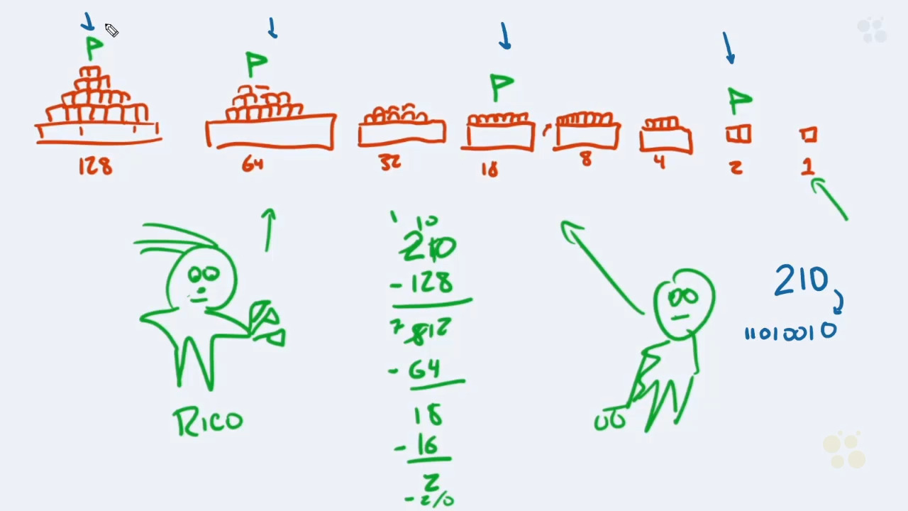

Which would be the binary equivalent for the number 58?

|  |  |  |  |  |
| --- | --- | --- | --- | --- |
| 58 | 2 |  |  | 128 |
| -32 | -2 |  |  | 64 |
| 26 | 0 |  |  | 32 |
| -16 |  |  |  | 16 |
| 10 |  |  |  | 8 |
| -8 |  |  |  | 4 |
| 2 |  |  |  | 2 |
|  |  |  |  | 1 |

00111010

***Practicing Decimal to Binary***

50

0 0 -32 -16 0 0 -2 0

00110010

100

0 -64 -32 0 0 -4 0 0

01100100

500